Geometric Nonlinear Analysis of a Cantilever Beam with BREP Reissner Mindlin Element

Objective:
To validate the Geometric Nonlinear Analysis of the Reissner-Mindlin shell element with different types of patches in the Kratos IGA application.
- Model Description:
The reference model is a cantilever beam subjected to end shear force, taken from “Popular Benchmark problems for geometric nonlinear analysis of shell” by K.Y. Sze et al. The tip model is given in Fig. 1, and displacement results are shown in Fig. 2. Please refer to the paper for further.
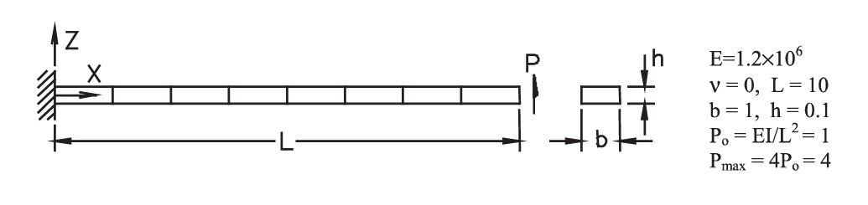
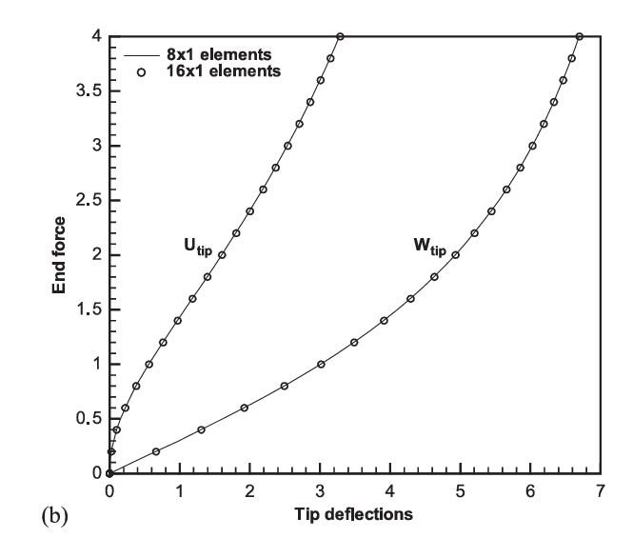
Fig 1: Model
Fig 2: Reference results – Tip Displacement

2. Study:
The following types of patches were studied.
- Single Patch

  - Single Patch - Old
In this model, the entire cantilever beam was modelled with a single-patch IGA shell element.

No of control points in X direction = 3
No of control points in Y direction = 16

The peak load (4 units) was reached by iteratively increasing the load by 10 load steps (step size 4/10 = 0.4). The solution did not converge in the first time step itself. Hence, analysis was changed to linear. Then the solver converged. With nonlinearity, the solution converged only up to a load of 0.2 units (Load Displacement Diagram – Fig.1).

Fig.1 - Load Displacement Diagram – RM Vs Kirchhoff

To check the influence of the degree of curve and load step, both were changed. The degree was increased by 1, and the load step value was decreased to 0.01. Then the solver converged up to 0.25 units.
Fig.2 - Load Displacement Diagram – Modified Thickness
It is observed that thickness affects convergence. When the thickness was increased from 0.1 to 1, then the nonlinear iterations converged until a displacement of 1.414 – Fig 2.

With the same thickness, the degree is increased by 2, and the load step value was 0.01 and the maximum load was 0.85. Till 0.85, the solver converged.

  - Single Patch – Modified Kratos

Now the mistake in Kratos is corrected. With the solver converged further till 0.2. After that, the solver again did not converge. An interesting observation here is that the Reissner Mindlin element had more stiffener behaviour than the Kirchhoff element. Both thickness was 0.1

Fig.3 - Load Displacement Diagram

